UNITED STATES

SENTENCING COMMISSION

Guidelines Manual Mobile Application Development

Request for Proposal

Volume 1 – Technical Proposal

RESPONSE TO USSC RFQ1193227

07 JUNE 2017

Submitted to:

Alex Mark

Contracting Officer (CO)

United States Sentencing Commission

One Columbus Circle, N.E., Suite 2-500

Washington, DC 20002-8002

Telephone: 202-502-1778

Email: amark@ussc.gov

Submitted by:

Jyothi Bhargava, President and CEO

Swingtech Consulting Inc.

7701 Greenbelt Road, Suite 501, Greenbelt, MD 20770

E-Mail: jbhargava@swingtech.com

Phone: (301) 850-1685

DUNS: 05233156



Disclosure Statement

*This RFP response shall not be disclosed outside the Government and shall not be duplicated or disclosed for any purpose other than to evaluate this submission. This restriction does not limit the Government’s right to use information contained in this RFP submission if it is obtained from another source without restriction. The data subject to this restriction is contained in all sheets marked with the following legend: “Use or disclosure of data contained on this page is subject to the restriction on the cover page.”*

TRANSMITTAL LETTER

June 7, 2017

Mr. Alex Mark, Contracting Officer

United States Sentencing Commission

One Columbus Circle, N.E., Suite 2-500

Washington, DC 20002-8002

Re: Request for Proposal (RFP) # RFQ1193227

Dear Mr. Alex,

On behalf of Swingtech Consulting Inc. (Swingtech), we are pleased to respond to the U.S. Sentencing Commission (USITC) Request for Proposal (RFQ1193227). As a rapidly growing SBA 8(a) firm, we are excited about the potential opportunity to deliver on this requirement. Our exceptional team of experts, to include our Chief Technology Officer who served for 8-years as the CIO of one of the largest Defense Agencies, consistently deliver rapid, high-quality results that are based on proven best practices and outstanding past performance. We have the unwavering capability to deliver excellence from day one and look forward to hearing back from you and your team.

Warmest regards,

Jyothi Bhargava

President and Chief Executive Officer

E-mail: jbhargava@swingtech.com

Telephone: (301) 580-4924

Facsimile: (301) 850-3389

Table of Contents

1 Executive Summary / Introduction 1

2 Business Size Standards (Compliance Citation) 1

3 Technical Approach 2

3.1 Task One - Making the Guidelines Manual and its Supplements (Appendices B and C) Available Through a Mobile Web App. 3

3.2 Task Two – Fixed Price - Incorporating additional functionality to the mobile web app of the *Guidelines Manual* (as described in Task One). 8

3.3 Task Three – Fixed Price - Incorporating “Jump to Specific Location” Functionality to the mobile web app of the Guidelines Manual (as described in Task One) 8

3.4 Task Four – Fixed Price - Making the Statutory Index (Appendix A) of the Guidelines Manual available as a specific reference search engine in the mobile web app. 9

3.5 Task Five – Fixed Price - Creating a Sentencing Range Calculator Tool to be available in the Mobile Web App. 9

3.6 Task Six – Fixed Price – Creating Calculator for the Drug guideline to be Available in the Mobile Web App. 9

3.7 Task Seven – Fixed Price (with Option Years) – Maintenance of the Mobile Web App 11

3.8 Task Eight – Labor Hour - Incorporating Additional Functionality to a Completed and Already Deployed Mobile Web App 11

3.9 Task Nine – Labor Hour - Technical Training to Commission Staff 11

# Executive Summary / Introduction

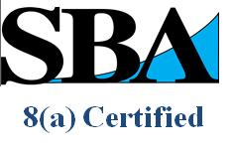Swingtech Consulting, Inc., is a Woman-Owned, U.S. Small Business Administration certified 8(a) and Small Disadvantaged Business (SDB). Founded in 2009 and headquartered in Greenbelt, Maryland, we are a professional services firm that does not just provide support - we solve deeply entrenched challenges! As a rapidly advancing integrator with a 8-year heritage of support to the Federal Government, we have earned the trust of every one of our customers by architecting, developing, implementing, and maintain cutting-edge (and secure) solutions for their 21st century mission challenges. Swingtech has developed a strong record of accomplishment in the midst of successfully serving our customers, to include (but not limited to); the Department of Defense Education Activity, the Office of the Secretary of Defense, the US Army, Department of Health and Human Services (HHS), Department of Education (DoEd) and many others. Our unparalleled qualifications, past performance, customer service and our ability to rapidly recruit and retain superstar talent are unmatched among our 8(a) industry counterparts and rival those of much larger organizations.

# Business Size Standards (Compliance Citation)

The following administrative data for Swingtech Consulting is intended to provide the USS with a comprehensive understanding of our company and our compliance with various standards.

|  |  |
| --- | --- |
| Full Legal Name | Swingtech Consulting Inc. |
| Founded | In the State of Maryland in 2009 |
| Key Leadership: | President and CEO: Jyothi Bhargava |
| Staff: | Approximately 40 Employees Worldwide |
| Financial Capability | Approx. $5.5 Million in gross revenues. |
| Socio-Economic Status: | U.S. Small Business Administration (SBA):  Woman Owned, 8(a) Certified (# 305581), Small Disadvantaged Business |
| GSA Schedule # | Contract # GS-35F-0149Y (IT Schedule 70) |
| Applicable SIN Designators | Special Identification Number (SIN) 132 51  Information Technology Professional Services (Automated Information System Design and Integration, IT Systems Development Services) |
| Facility Clearance | Active Secret (CAGE Code: 6AKF7) |
| Certifications: | Project Management Professional (PMP), DoD 8570.1M Level 3 Certified Professionals and IT Infrastructure Library (ITIL) v3 Certifications |
| Quality: | ISO 9001:2008 and CMMI Development Level 2 Certified Processes |
| Federal Tax ID | 26-4774738 |
| DUNS | 052331560 |
| Business Address | 7701 Greenbelt Road, Suite 501, Greenbelt, MD 20770 |
| SAM and CAGE | YES | 6AKF7 |
| NAICS Codes | 541511 | 541512 | 541513 | 541519  541611 | 541618 | 541690 | 561320 |

# Technical Approach

First and foremost, we work with our customers to build compelling web based (mobile) apps that provide immediate value and lasting excitement. While our approach promotes evolutionary development, continuous improvement, and flexible responses to change(s), our inherent understanding of mobile and web based technology allows us to bring an unprecedented level of expertise to the USSC, like no other company can/will. We build solutions that scale TO YOUR NEEDS, all while gaining an increased understanding of your short and long range mission needs. We will merge this collective information with everything our team knows about mobile, while assessing any and all possible challenges and identifying ways/means to overcome them.

We will work towards the goals established in Tasks 1-9, while also engaging with your team every step of the way to prepare and assess frameworks for the mobile app in the form of wireframes and prototypes. It is also important to note early on that we recognize first impressions are all about design. We will put our passion for cutting-edge design to work and will integrate the same into our wireframes for review and consideration.

For the purposes of our work plan, our development process will be broken down into Agile-based sprints that are based upon specific feature sets known as ‘user stories’. Our Agile processes have been successfully incorporated across our entire customer base. As Agile results in iterative development, a decision can be made at the end of each sprint as to whether to deploy the working increment into the production environment. The key concept of each Swingtech sprint is to provide a highly collaborative environment that delivers functional solutions, while providing key value to our customers. We assure you that these processes (and the tools utilized, such as JIRA) will allow for the regular review and assessment of our build, every step of the way. The net result of these ‘sprints’ will be seen in your secure, functional mobile application that exceed every one of your goals the first time! Recognizing the 6-month timeline, and our intent to deliver stellar results far faster, we are proposing the following high-level steps (as integrated into weekly sprints).

* Design User Interface / User Experience artifacts which includes Site Architecture Plan and Diagrams, Work Flows, User Interface Design and Wireframes for the Guidelines Manual, to include the chapters, parts, sub parts and guideline sections for Appendix A, statutory provisions for Appendix B and amendments for Appendix C.
* Establishing the USSC mobile application development environment, to include the proven technologies cited herein.
* Coordinate with stakeholders for the approval on the Site Architecture, Work Flows, User Interface Design and Wireframes.
* Establishment of the user stories and integration of the same into the weekly sprint cycle.
* Establishment of the production environment, in conjunction with coordinated (final) QA, cybersecurity and beta testing. Release of USSC’s candidate build into production.

## Task One - Making the Guidelines Manual and its Supplements (Appendices B and C) Available Through a Mobile Web App.

In support of the USSC’s requirements, we are proposing an **offline-first approach** to enable the Guidelines Manual to be accessible anytime and anywhere, with or without internet connectivity. As originally framed by the Google Team, Swingtech prefers to utilize a Progressive Web Application (PWA) approach to deliver reliability (even amidst uncertain Internet conditions), rapid response (smooth interactions) and an engaging look and feel, all of which collectively deliver an immersive user experience every time! Our PWA approach will rely on several key elements for the USSC, to include:

* Integration of a responsive design – This will ensure that the content (the manual) displays well on mobile, tablet and desktop form factors, to include but not limited to nearly every major browser across the Apple, Windows and Linux mobile platforms.
* Integration of offline rendering capabilities whereas the web page can be viewed and used without network connectivity. This will also cover unstable networks, thereby ensuring a high quality user experience in all instances.
* Leveraging the Microsoft Word version of the Guidelines Manual and integrating the same into a client and server side offline database framework. This two-tier offline first approach will ensure that data is rendered to the client in HTML 5 format, via JavaScript Notation (JSON) or XML, from a server-side DB engine. While this achieves the visual elements at a high level, we are proposing the use of PouchDB as our client-side offline capability. PouchDB is an open-source JavaScript database inspired by Apache CouchDB that is designed to run well within the browser. It was created to help web developers build applications that work as well offline as they do online. In doing so, it enables applications to store data locally while offline, then synchronize it with CouchDB and compatible servers when the application is back online, keeping the user's data in sync no matter where they next login.
  + This step (element) will allow for effective and efficient automated reprocessing of the updates in the future. However, it will require some degree of early effort to ensure that the server side database architecture is properly designed.

The following diagram demonstrates this process at a high level:

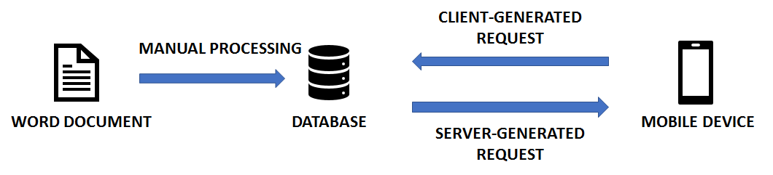

Once the information has been assimilated into the database, the server side application will also be able to identify the organization structure of the content. This structure would be encoded into the JSON format and passed to the client-side application. It would then be displayed in a collapsible interface divided into chapters, parts, subparts, and guideline sections with access to tables and figures, as specifically requested in the PWS.

**Requirement: Neat presentation in the form of heading and description in every screen**

Just as with Agile development, user interface design (and presentation) to Swingtech’s SMEs is an iterative process. We therefore build your UI not just once, but three times, with successively higher-fidelity and more complete wireframes and prototypes. To allow time for these iterations, we need to get started on the project swiftly. We will ensure that the header and description are integrated into every screen throughout each of these cycles as well. Once these cycles are complete, we will have a solid idea of how user engagement and screen flow will take place on your specific application. Our UI design experts will then work with your team to then convert the wireframes into clean, attractive and functional interfaces. The ease and quality of Swingtech’s User Interface and User Experience design is what steers our customers towards coming back to us time and time again.

**Requirement: Aesthetic reading experience (text size can be adjusted for content)**

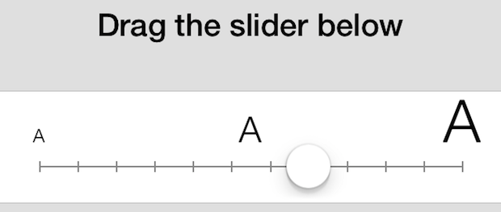Swingtech recognizes that font sizes (for reading experiences amidst mobile layouts) are typically set in Ems, rather than pixels. This commonly ensures that the font size is relative and ready to ‘adjust’ to different screen parameters. With this understanding of the client side requirements, we will design buttons to increase size of fonts based on a visual slider, as conveyed in the diagram above. We will also allow for static setting-type adjustments based on our font size and EM conversion chart.

**Requirement: Full-text search and other advanced search options, including search through chapters, sections and content**

Whether the content is online or offline, Swingtech will implement a very efficient and accurate full-text search engine to analyze the text, index it and deliver near instantaneous results across the chapters, sections and content. In recognizing the USSC’s utilization of Apache Solr, and our vast experience with the same, we are recommending Solr integration for this purpose. For reference (as conveyed by Apache) Solr is a standalone enterprise search server with a REST-like API. You put documents in it (called "indexing") via JSON, XML, CSV or binary over HTTP. You query it via HTTP GET and receive JSON, XML, CSV or binary results.

Our approach is ideal for full-text searching, or using search in specific chapters, parts, sections and content. We will also design a global search option to search all appendices based on keyword. The search results will also be returned as a hyperlinked list for ease of bookmarking.

**Requirement: Listing screen that breaks down the chapter, part, subpart, and guideline sections of the manual**

With regards to the Listing Screen, Swingtech operates off the principle of “Excellent Interface Design is Design That Is Not Noticed”. In support of the Listing Screen requirements, we recognize that people don’t like learning new ways of accomplishing the same tasks. For that reason, we will employ our wireframe techniques (and tools such as Balsamiq) to effectively ‘sketch’ the major screens, to include the Listing Screen, and render the full resolution, full-color designs for approval and integration purposes. We recognize that many of the aforementioned requirements are UI/UX centric, hence our integration of one of our key designers into the project itself.

**Requirement: Display current path in every screen/section so users know where they are**

To support the task to display the current path in every screen and in every section so that the users know where they are, Swingtech will design a breadcrumb path for all levels on the page navigation and will allow the user to navigate back to last page visited.

**Requirement: Browse through sections with swipe gesture in a clutter free design**

Swingtech will design and develop pages to navigate previous or next button based on figure gesture when on a mobile device (offline mobile application version) and will allow the feature to load from the database at first from the database server and stored offline for rendering on devices across multiple browsers.

**Requirement: Unlike other features set forth in the tasks below, the full content Manual should be accessible while offline**

Utilizing the Appcelerator Framework (https://www.appcelerator.com), CouchDB, PouchDB, JSON and HTML 5 (as aforementioned), we will ensure that the full content manual is accessible while offline. CouchDB, specifically, is a NoSQL database system that manages JSON documents and PouchDB, a JavaScript implementation of CouchDB for integration with JavaScript based browser based apps, were chosen for their proven ability to function without an internet connection and their ability to support both bi and uni-directional synchronization from source to target or target to source.

While PouchDB supports all the browsers, there are some limitations when it comes to how much data it can store, depending on the browser. To avoid this limitation, we will use PouchDB in combination with the SQLite integration capabilities inherent with Appcelerator. The mobile web app which is a combination of HTML, JavaScript and resource files (images, local JSON database files) can/will be packaged into a zip file and can be deployed on any web server which can render HTML pages. For hosting of the mobile web app, Swingtech has expertise in providing FedRAMP compliant cloud analysis and hosting solutions for variety of our clients so we are well aware of the processes involved with solutions such as Amazon AWS GovCloud. The key AWS services to support the mobile web app in this case include EC2, ELB, VPC, and S3 all of which are AWS GovCloud compliant. All the AWS services and the respective components are illustrated in the picture below. We will follow a similar approach for the USSC Dev, UAT and Production environment, as may be required.

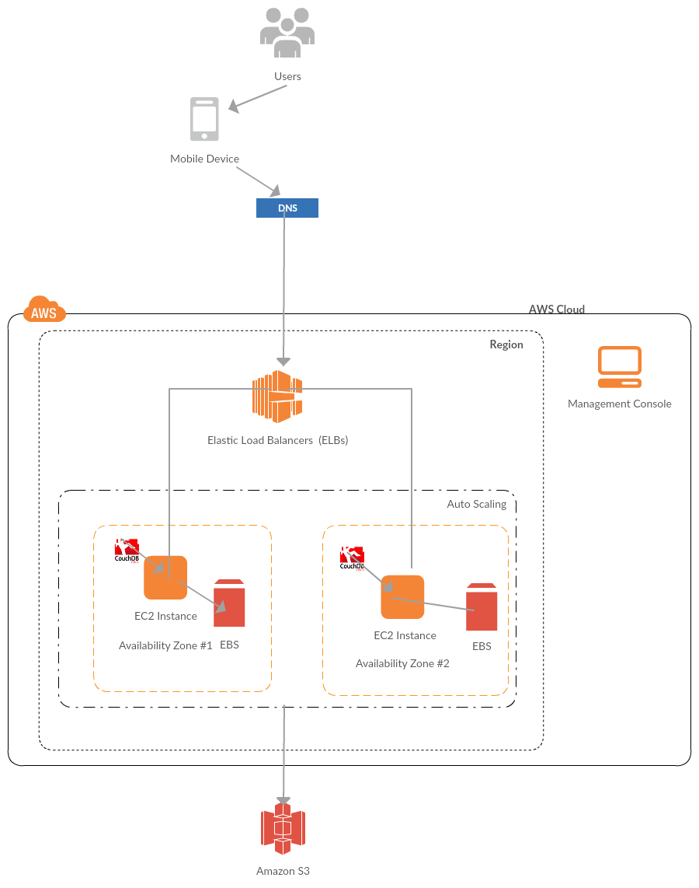

During the initial stage of the project kickoff, Swingtech will collaborate with the USSC CISO to validate any and all security controls for AWS GovCloud. Based on the current information provided in the RFP, there is no sensitive or PII information collected, but Swingtech will confirm this during the project kickoff week and will identify the additional security controls required to implement for the mobile web application.

**Requirement: Converting the supplements to the Guidelines Manual (i.e., Appendices B and C) to HTML format.**

Swingtech will convert Appendices A, B and C into HTML5 so as to future proof the requirement and unlock the potential of document assets in a mobile world. We will follow similar process to convert all the volumes and amendments in Appendix C to convert them into HTML5, while conducting extensive QA validations to ensure the success of the conversion.

Our conversion tools do not have external dependencies, plugins, additional downloads or app installations. The results of the conversion will be 100% HTML5, thereby ensuring interoperability in all major browsers regardless of the platform. Some of the features that USSC will be able to leverage with our solution include the ability to jump to the page that they want either by typing in the page # or select the page # from the drop down. Users will also have the ability to easily zoom in and out, while viewing the page in presentation, magazine or in continuous mode. As part of this process Swingtech will also review all the generated HTML pages and modify the pages to add anchor tags for users to jump to references when they want to navigate to those sections from anywhere in the web app.

**Requirement: Making the supplements to the Guidelines Manual (i.e., Appendices B and C) available in the mobile web app of the Guidelines Manual. The mobile web app version of the supplements should provide the following general features:**

As an overarching methodology, Swingtech will implement the solution described in section A above for the supplements to the Guidelines Manual from Appendices B and C. The users will be able to browse through the statutory provisions and amendments so the headings and descriptions are shown in each screen they are in and they will be able to increase and decrease the text size of the content for aesthetic reading experience. As explained in section A, we will utilize PouchDB full-text capabilities. With the use of PouchDB we can analyze text, index it, and provide a simple but powerful API for querying. This approach is suitable for apps that must work in online AND offline modes.

**Requirement: All features of the mobile web app should be interconnected by making all references to other parts of the Guidelines Manual and its supplements, such as guideline sections and amendments, function as hyperlinks for immediate user access**

Swingtech has built responsive mobile web applications for the Centers for Medicare and Medicaid Services, the Department of Defense Education Activity and many others. We utilize the best practices from U.S Digital Services Playbook and, as mentioned in Section B herein, the HTML5 will be modified to make all references to other parts of Guidelines Manual and its supplements such as guideline sections and amendments by adding anchor tags to jump to specific location on an HTML5 page.

**Requirement: Provide as a feature of the mobile web app a quick reference chart that provides the application instructions of the sentencing guidelines with hypertext.**

Swingtech will design and develop a Quick Reference Chart for the Mobile Web App with links to key areas. We will ensure full compliance with this requirement.

**Requirement: Direct access from the main menu of the mobile web app to specific tables and figures in the Guidelines Manual.**

Swingtech will design and develop a mobile responsive menu system to navigate the key areas of the mobile web app, to include tables and figures from the main menu of the Guidelines Manual.

**Requirement: Include a feature in the mobile web app that allows users access to previous versions of the Guidelines Manual through links to the Commission’s website at www.ussc.gov.**

Swingtech will design and develop an archival page that includes a list of the versions of the Guideline Manual, while informing users of the version number, changes (searchable, if requested) and release date.

## Task Two – Fixed Price - Incorporating additional functionality to the mobile web app of the *Guidelines Manual* (as described in Task One).

Swingtech will design and develop the features to support the bookmarking of pages, highlighting of text and saving for later use, and creating notes to be saved to later use. To accomplish this task, Swingtech will leverage web page highlighter applications that provide API services that can be easily integrated into the mobile web application. These services, for architectural discussion, include Diigo, Pocket, XMarks and Papaly. While we have experience with all of these API platforms, we will articulate the pros and cons of each prior to any integration activities. Additionally, utilizing the above API services, Swingtech can support the sharing of text content and custom notes through any text related application (e.g., SMS, email), as well as all possible social networks available on device (e.g., Facebook, Twitter, Google+).

## Task Three – Fixed Price - Incorporating “Jump to Specific Location” Functionality to the mobile web app of the Guidelines Manual (as described in Task One)

To incorporate the “jump to specific location” functionality, Swingtech will design and develop text links to specific HTML Pages for core content and create sub list of reference links if the text link has more than one reference point. Here are some steps that Swingtech would take to achieve the “jump to specific location” functionality:

* We will give the object or text to link to a name. In this scenario, the page you want to link to and the page the link is on the same HTML page. Using the following (example) object:

Example:

**§2B1.1(b)(1)**

* Take the name you've chosen and insert it into an opening HTML anchor link tag.

Example:

<a id="**§2B1.1(b)(1)** ">

* Place that complete opening <a> tag from above before the text or object *you want to*link*to*, and add a closing </a> tag after. Doing this sets the location of link. This is what we will code:

Example:

<a id="**§2B1.1(b)(1)**">**§2B1.1(b)(1)**"></a>

* Create the hyperlink that will take the user to that text or object. Now, we will add a typical hyperlink HTML markup, but in the part where we typically include a URL, we will include the pound symbol (#) then the name of the object we will link to. Here's what it looks like:

Example:

**<a href="**#**§2B1.1(b)(1)"> §2B1.1(b)(1)</a>**

Now we have a functioning hyperlink between two pieces of content on the same page. These exact results, on a broader scale, will be delivered to the USSC in support of Task 3 herein.

## Task Four – Fixed Price - Making the Statutory Index (Appendix A) of the Guidelines Manual available as a specific reference search engine in the mobile web app.

Swingtech will design and develop an efficient search engine which will enable the user to input the statue of conviction. The search engine will fetch the results from either online or offline depending on the availability of network connectivity and will display a list of applicable guideline sections as hyperlinks. This result set will enable the user to click on the hyperlink and access the corresponding guidelines in a HTML page.

## Task Five – Fixed Price - Creating a Sentencing Range Calculator Tool to be available in the Mobile Web App.

To support the creation of the Sentencing Range Calculator Tool, Swingtech will design and develop a search feature to access the sentencing range. The user will input offense level and criminal history category and the calculator will access database to run formula and list of results will return the applicable guideline range as shown in the below example.

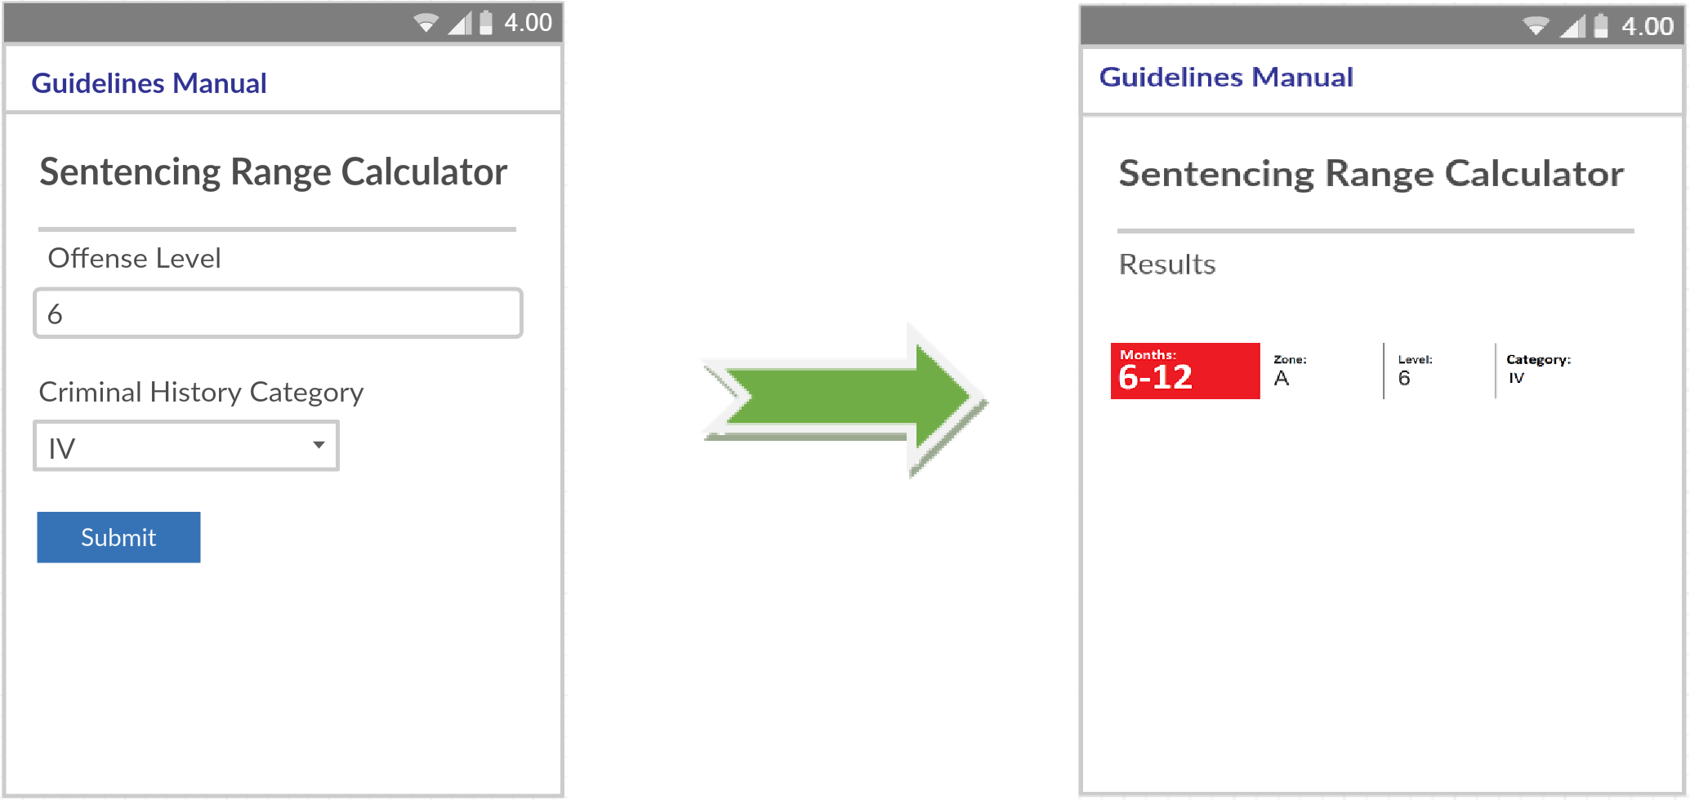

## Task Six – Fixed Price – Creating Calculator for the Drug guideline to be Available in the Mobile Web App.

**Requirement: Creating a Drug Quantity Calculator that enables users to input the quantity of the controlled substance involved in the offense in any standard unit of measurement and get, as a result, the applicable offense level.**

To support the creation of a drug quantity calculator, Swingtech first will convert the drug quantity table from Guideline Sample §2D1.1 into a database with controlled substances and quantity and related offense levels. Swingtech will design this database and will ensure that all rules for the offense levels are entered and validated. Once the database is designed and validated by our Swingtech mobile web app developer, the developer will then design the mobile web app front end with our UI/UX designer expertise on how users can input the quantity of the controlled substance (either entered as ounces, pounds, kilograms, milliliters, including units if the quantity is pills, tablets or capsules) and then the user selects the controlled substance. Swingtech will write an algorithm which fetches the data from the database and will output the result of the base offense level along with the controlled substance selected along with the quantity as shown in the sample illustration:

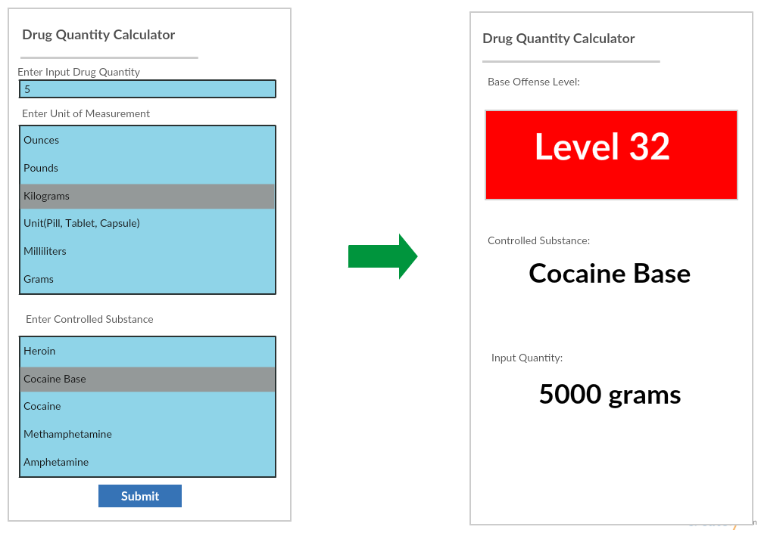

**Requirement: Creating a Drug Equivalency Calculator that enables users to input the quantity of the controlled substance involved in the offense in any standard unit of measurement and get, as a result, the equivalent quantity of marijuana in the metric unit for mass.**

In support of the request to calculate the equivalent quantity of marijuana, Swingtech will consider the Drug Equivalency Table from Application Note 8 (D) of the Guidelines Sample document and convert the table into a similar database structure for drug quantity calculator. We will leverage PouchdDB on the client side for offline storage and CouchDB on the server side for online storage. The users will be able to enter multiple drug quantities and by using the drug equivalency table, Swingtech will convert the quantities based on the rules of conversion and provides the appropriate quantity of marihuana in the metric unit of mass along with the offense level as shown in the following sample illustration:

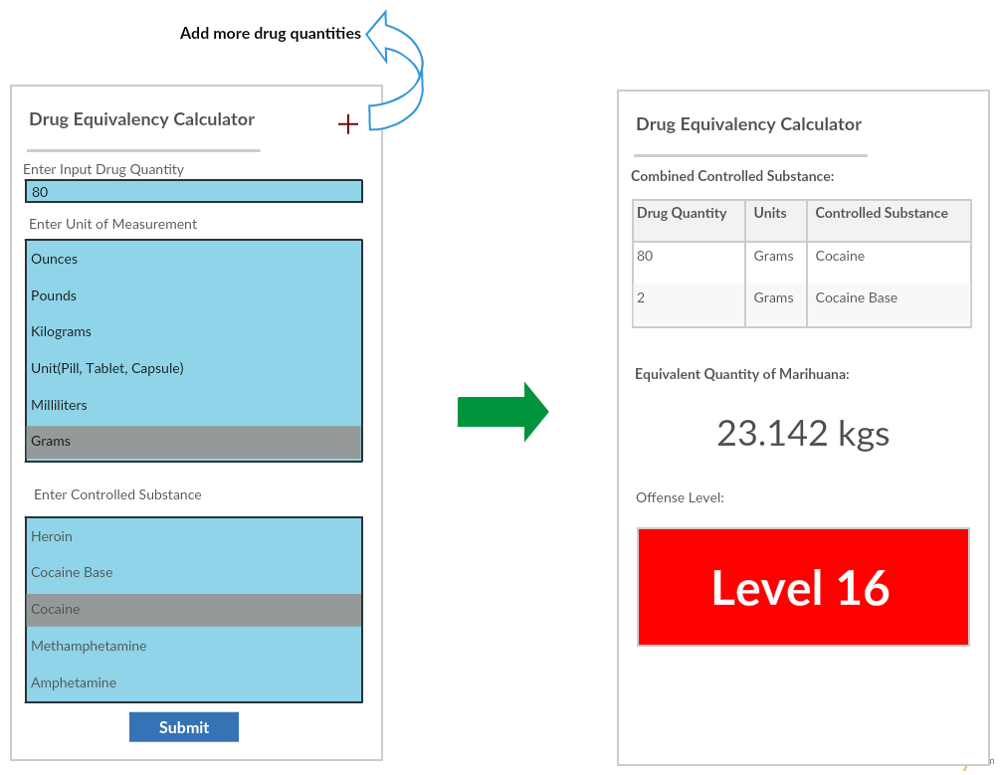

## Task Seven – Fixed Price (with Option Years) – Maintenance of the Mobile Web App

Swingtech will maintain and update the mobile web application as required in support of Task 7. As the USSC updates their editions of the Guidelines Manual and its supplements, Swingtech will maintain versions of the editions in its database with version numbers and release dates and will republish the HTML pages. Any production break fixes will be managed through JIRA issue tracker, as required. Swingtech’s Developers will resolve the issues in agreed upon weekly sprints, to include resolution of any/all changes to HTML, JavaScript frameworks and/or database schema elements.

## Task Eight – Labor Hour - Incorporating Additional Functionality to a Completed and Already Deployed Mobile Web App

In support of Task 8, Swingtech will work with the USSC to identify if the additional functionality is in scope within task one to task eight and if additional functionality is outside the task one to task six, then those tasks will be entered as backlog items in JIRA during the weekly sprint planning meetings. Upon agreement with USSC stakeholders, these backlog items will be revisited after tasks one to six are completed and tasks are prioritized by USSC in order of need and will be worked up on by the developers in that sprint.

## Task Nine – Labor Hour - Technical Training to Commission Staff

|  |  |
| --- | --- |
| **A Proven Approach to Delivering Against Complex, Enterprise-wide Training Needs**  **(Content Management, Technical Maintenance, Hosting, Deployment, Etc.)** | |
| **Proven Training Excellence**  **For USSC** | * **Global Experience**: Swingtech’s investment in leading-edge training development and delivery capabilities powers our delivery of high quality training initiatives. * **Rapid, Responsive Training Development**: A decade of investment in training design capability enables us to quickly develop and deliver timely, tailored training programs**.** * **Role-based Training for any Skill Level**: Swingtech will provide the USSC with a role based training plan for all of the disciplines cited (and more), to include: content management, technical maintenance, and hosting and deployment of the mobile web app. Swingtech’s SMEs will deliver the training, while ensuring a future proof approach to workforce development. |
| **A Modern Approach to USSC Training** | * **An Approach that Transcends Buzzwords**: Swingtech will: a) apply a proven training needs analysis framework, b) develop and deliver classroom, mobile and web-based courses, and c) track results. We will take blended training from overused buzzword to a results-oriented approach for the USSC. * **Proven Blended Learning Approach**: Swingtech has successfully applied blended learning techniques to our courseware and delivery. We are confident we can deliver similar results to advance this training requirement. * **Data Analytics to Drive Continuous Improvement**: Swingtech’s approach to data analytics is based on Kirkpatrick Level 3 principles and focuses on the collection of knowledge absorption metrics to continually improve training curriculum. Additionally, our approaches are based on a customized version of the ADDIES framework, thereby providing a lifecycle approach to courseware development and sustainment. |
| **Disciplined Delivery & Execution** | * **Disciplined, Results-Oriented Management Approach**: For low risk execution such as this one, our approach to training development and delivery is founded on ISO 9001:2008 certified training processes and backed by proven past performance supporting DoD, Federal Civilian and private sector training programs. * **Experienced Instructors Ready to Roll**: We have a team of instructors with experience operating in our nation’s most challenging environments. Our instructors bring this experience to bear in the classroom, which aids in learner engagement and knowledge transfer. |